AN INTRODUCTION TO APOLOGETICS

- WHAT IS APOLOGETICS?
The task of developing and sharing arguments for the truth and rationality of Christianity and the falsehood and irrationality of alternatives with the aim of strengthening the faith of believers and provoking non-believers to consider Christ

- WHAT ARE THE ORIGINS OF APOLOGETICS?
  - The Concerns Of Justin Martyr And Others Of The 2'nd Century
    - To Defend Christianity Against False Accusations
    - To Argue For The Truth Of Christianity On The Basis That It Fulfilled O.T. Prophecy
    - To Demonstrate That Christianity Was Superior To Or Even Fulfilled Greek Philosophical Ideas
  - Tertullian's Rebuttal
  - True Apologetics Originated In The New Testament (Luke / Paul)
- WHAT IS THE PURPOSE [TRI-FUNCTIONALITY] OF APOLOGETICS?
  - Arguments For The Truth Of The Christian Faith (Vindication)
  - Arguments Refuting Accusations Made Against The Christian Faith (Defense)
  - Refutation Of Opposing Beliefs (Offense)
- HOW DOES APOLOGETICS RELATE TO EVANGELISM?
- APPROACHES TO APOLOGETICS
  - Depending On The Approach To Knowing God (Epistemologies)
  - Depending On The Way Arguments Are Constructed
    - Classical Method (William Lane Craig; R.C. Sproul; Norman Geisler)
    - Evidential Method (Gary Habermas; John W. Montgomery; Clark Pinnock; Wolfhart Pannenberg; Josh McDowell)
    - Cumulative Case Method (Paul D. Feinberg; C.S. Lewis)
    - Presuppositional Method (Cornelius Van Til; John M. Frame; Greg Bahnsen; Francis Schaeffer)
    - Reformed Epistemology Method (Alvin Prantinga)
  - Depending On Kenneth Boa's Way: Four Methodologies
(See Boa's Table Chart For Details And Characteristics Of The Four Approaches To Apologetics And The Way They Tend To Deal With The Most Common Apologetic Issues)
- COMMON OBJECTIONS TO THE TASK OF APOLOGETICS
  - Objections From The Bible
    - Scripture Does Not Need To Be Defended
    - God Cannot Be Known by Human Reason
    - Natural (Depraved) Humanity Cannot Understand God's Truth
    - Without Faith It Is Impossible To Please God
    - Jesus Refused To Give Signs To Evil Men
    - You Do Not Answer A Fool According To His Folly
    - Apologetics Is Not Used In The Bible
  - Objections From Outside The Bible
    - Logic Cannot Tell Us Anything About God
    - Logic Cannot Prove The Existence Of Anything
    - No One Is Converted Through Apologetics
- A BIBLICAL CASE FOR THE TASK OF APOLOGETICS
  - Acts 17:1-4 "...and three sabbath days reasoned with them out of the scriptures, opening and alleging..."
  - Acts 17:22-34 "...whereof he hath given assurance (proof) unto all men, in that he hath raised him from the dead."
  - Acts 26:24-29 "But he said, I am not mad, most noble Festus; but speak forth the words of truth and soberness (reasonability)."
  - Romans 1:18-20; 2:14-15 Romans 1:19 (KJV) "Because that which may be known of God is manifest in them; for God hath shewed it unto them." The evidence of Creation & Conscience.
  - II Corinthians 10:3-5; II Corinthians 10:5 (KJV) “Casting down imaginations, (demolishing arguments) and every high thing that exalteth itself against the knowledge of God, and bringing into captivity every thought to the obedience of Christ;”
  - Philippians 1:7,16 "...and in the defence and confirmation of the gospel..."
  - I Peter 3:13-16; I Peter 3:15 (KJV) “But sanctify the Lord God in your hearts: and be ready always to give an answer to every man that asketh you a reason of the hope that is in you with meekness and fear"
- THE DYNAMIC OF APOLOGETIC DIALOGUE
  - A Context For An Apologetic Interchange
    - The Relationship Between The Two Parties
    - The Immediate Situation
    - The Broader Social, Cultural, Historical Context
  - You: The Apologist
  - A Questioner (See The Circumstantial Table)
  - A Question/Issue
  - An Answer
  - Always Bring The Conversation Back To Christ

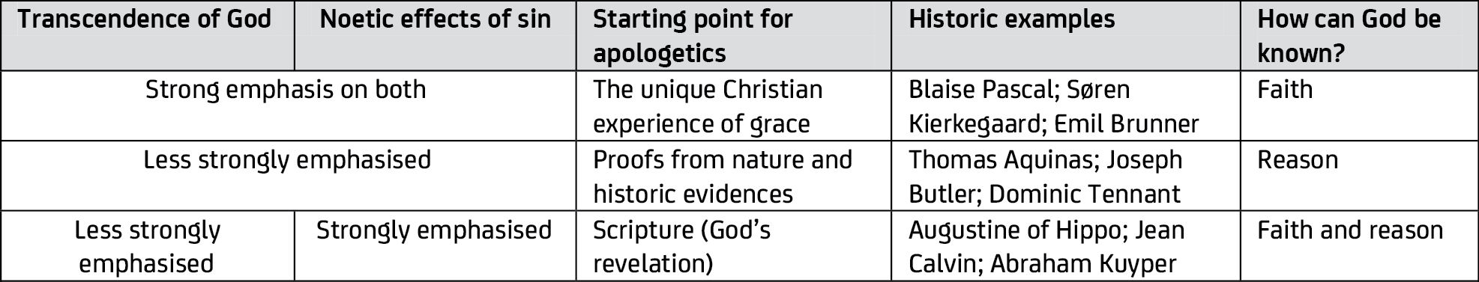
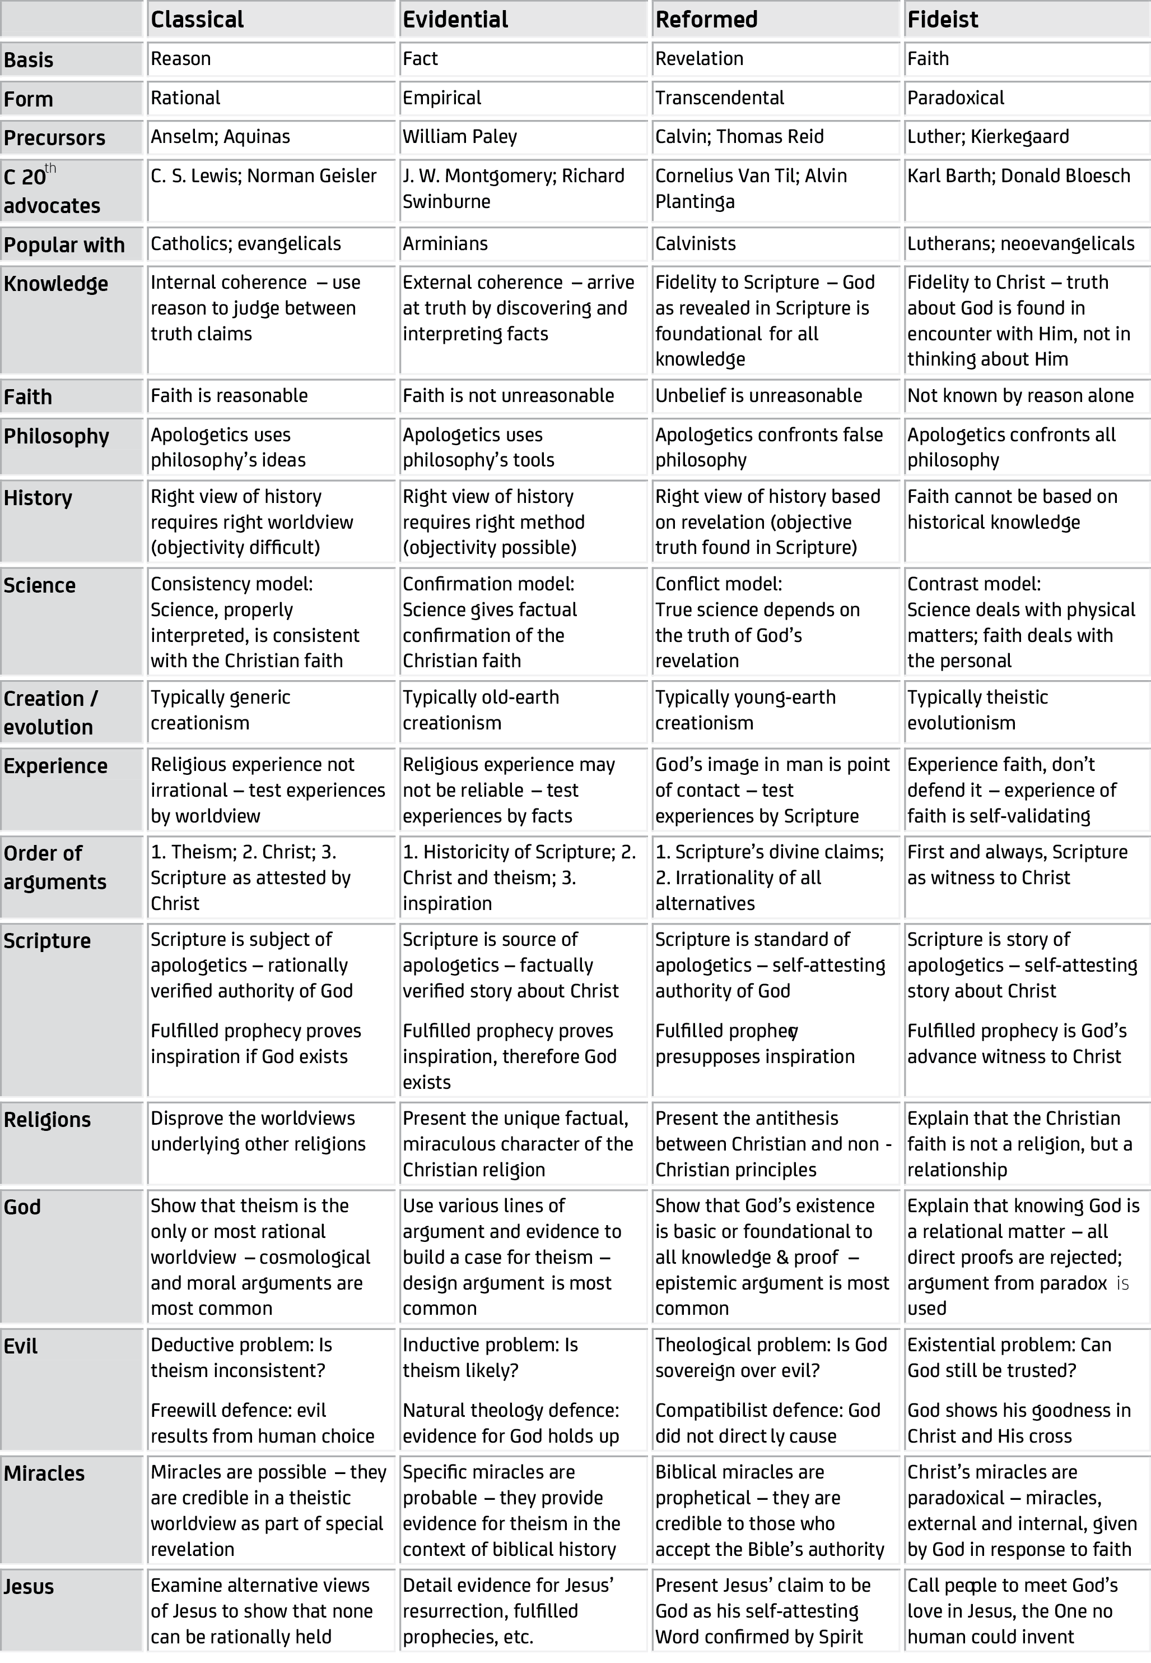
APOLOGETIC STRATEGIES
IN
EVANGELISTIC ENCOUNTERS

Stance regarding faith | Dominant approach | Typical questions / objections | Possible apologetic arguments
Disinterested / ignorant | Fideism | It doesn’t matter to me if God exists or not. | If God exists, it matters! [Pascal’s Wager] (F)
Sceptical | Reformed apologetics | God may be real to you, but he’s not to me. | Is Jesus real enough for you? (F)  You live every day as if God exists. (R)
Confused | Classical apologetics | How do you know there is a God? | Without God, there is no meaning. (R)  No other worldview makes sense. (C)  There are many lines of evidence. (E)
Has specific objections | Evidentialism / Classical apologetics | The stories in the Bible are hard to believe.  Why must we believe in the God of the Bible?  How do we know Jesus rose from the dead?  Wasn’t Jesus just a great prophet or a good man? | If God exists, nothing is too hard for him. (C)  God fulfilled prophecy and did miracles. (E)  The tomb was empty and people saw Jesus. (E)  Great prophets and good men don’t claim falsely to be God. (C)
Feeling challenged | Reformed apologetics | Why is Christianity alone the truth? | God’s claims in the Bible are exclusive – other religions cannot be true. (R)
Lingering doubts | Fideism | I’d like to believe, but I’m not sure. | Read the Gospels and get to know Jesus. (F)

